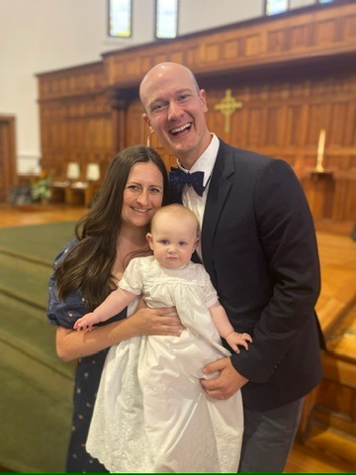
Sophia Susan Burchhardt with her parents, Katie and Chris, on her baptism day, November 17, 2024
You Are Loved: Stories About the Ones We Have Baptized
January 11, 2025
The Baptism of Our Lord
Rev. Christine E. Burns
This is a story that begins with a baptismal gown, but it’s not really about a long white gown at all. It’s a story about love across generations. Isn’t that so much of what passing on our faith and following Jesus is all about? Jesus gave us this amazing commandment that we are to love one another, and that we are to love God with all our heart, soul and mind. And in the story of baptism, we get to intertwine the two with the mingling of water and hands that bless and love and baptize.
Last spring, our eldest daughter Katie came to me and asked for the baptismal gown. I knew exactly where it was as I tend to be the keeper of all things in the house. I had dry cleaned the gown after Lydia used it 22 years ago but when we pulled it out of the bag it looked terrible! Huge yellow stains up and down the front and the back and I didn’t know if we could ever get it clean. Afraid to wreck it, I sent it home with Katie and told her to do what she could with it in enough time that if she needed to find something different for her baby Sophie to wear for her baptism scheduled months later in November that there would be plenty of time. Using the wisdom of neighbors who sew and the internet, Katie tried Oxi-Clean and through its patented combination of sodium carbonates, the yellowing stains of age and oils lifted from the surface and the old gown was restored to its original white color. What a gift.
The story of this old gown is a story of a great-grandmother’s love for Katie. When Katie was a baby, her great-grandmother made this gown for her baptism. And she wore it when she was baptized at Needham Congregational Church held by her mother Susan and father Reed. This very gown was then worn by her younger sister Julia a few years later and then by Lydia years after that. Each time, the gown was worn, it covered the newborn in familial love stitched by a great-grandmother who was no longer around, and yet, her legacy in love remained as each baby was dressed in this family baptismal gown.
This November, Reed and I joined the rest of the family at Circular Church in Charleston, a United Church of Christ in the heart of downtown Charleston. The historic building is circular and built of bricks to prevent fire. When we arrived at Katie and Chris’s church, the senior minister, Rev. Jeremy Rutledge, generously allowed Reed to officiate at the baptism of Sophie. Sitting in the front pew watching Reed, who goes by “Pops” hold Sophie and baptize her using the same words that Christians have for two thousand years, “I baptize you in the name of the Father, the Son and the Holy Spirit” was so moving. Sophie was dressed in the same baptismal gown, newly whitened and ironed and now another generation of Baer great-grandchildren was wearing this gown made with love. We are clothed in the love of our ancestors literally in this case as Sophie wore her mother’s baptismal gown. The church sang the song we sing at our church “I Was There to Hear Your Borning Cry” and the congregation waved blue ribbons and Sophie proudly waved as she was paraded around the congregation. Here was a child surrounded and held by the love of her family and held by the love of this congregation that promises to “love, support and care” for Sophie and her parents as she grows.
We each need this. We need to be reminded that we were once that child, even if we were never baptized, or don’t know if anyone explicitly dedicated time to bless and honor you as an infant or a believer, here is the Good News, God has always called and chosen you as God’s beloved child. God is calling your name, the one you were given at your birth or the one you have chosen today, God will call your name over and over throughout your life saying “You are my beloved child. I love you. I have chosen you from the moment you were born, and I will love you to your last breath. I will be the one who carries you home. There will never be a time when God, our parent, stops loving and calling us God’s own. We are loved beyond measure.
In today’s lectionary reading, we learn of the Baptism of Jesus. This is the time in the lectionary cycle where we remember the baptism of Jesus and we reflect on our own baptisms. While most of us in the UCC and many other denominations were baptized as infants, here is a chance to remember that we are loved by God and that love began in the waters of the womb and were blessed by the waters of our baptism.
In the story Luke tells of Jesus’ baptism in the River Jordan the details are quite ordinary. He is baptized as an adult, and it is only after this baptism that Jesus begins his official life and ministry as the Jesus we know and talk about in the Gospels as the Way, the Truth and the Life. John was baptizing everyone. He was calling to the people in the wilderness, reminding them of the prophet Isaiah that said, “the voice of one crying in the wilderness: prepare the way of the Lord, make his paths straight, Every valley shall be filled, and every mountain and hill shall be made low, and the crooked shall be made straight, and the rough ways made smooth: and all flesh shall see the salvation of God.” (Luke 3:4-6)
There are so many remarkable, ordinary aspects about Jesus’ baptism. He didn’t do anything special, different, or extraordinary. Jesus entered the waters of the River Jordan, just like all the ordinary folks around him. He prayed. He asked God for help. At this point, he had done no miracles, no disciples were organized around him, he hadn’t preached to the masses or been tempted in the wilderness. He was still in the eyes of the world he lived in, a rather ordinary man.
Early Christians in the Church were embarrassed by this baptism story of Jesus. Where were the miracles? Where was the big conversion experience? Why did the Holy Spirit, an all-powerful symbol of the divine appear in the weak form of a dove? A dove wasn’t as powerful as a hawk or an eagle. A dove wasn’t nearly as powerful as a mammal like a stallion or a bull. It was only a dove, descending to the waters and landing on Jesus’ body. And then, a voice came from heaven saying, “You are my Son, the Beloved; with you I am well pleased.”
Last week we celebrated the Epiphany and as we continue to wonder where we see epiphanies or revelations in our own lives, I am struck by the insight of Debie Thomas who writes, “So I stand at the edges of this week's Gospel reading and find myself afraid to leap. How shall I bridge the gap between an ancient Voice and a modern silence? Heaven opened. A dove descended. God spoke. Really? I want to believe this. I do.
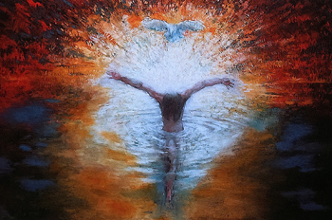
But to accept the supernatural in Scripture is to plunge into a sea of hard questions. If God spoke audibly in the past, why doesn't he do so now? If he does, why haven't I heard him? Do I lack faith? Has he retreated? Changed? Left?
Or are the ancient stories of Epiphany figurative? Was the dove, in fact, just a dove, and the voice from heaven no more than a nicely timed windstorm? When we speak of epiphanies, are we really just trucking in metaphor? Perhaps God should be in scare quotes. I had a "spiritual experience." I felt "God." He "spoke" to me. Isn't it embarrassing nowadays to believe in miracles?
Here's my real problem with this liturgical season: I always, always have a choice — and most of the time, I don't want it. I expect God's revelations to bowl me over. I expect epiphany to come in ways that leave me choice-less, powerless, and flattened in awe. I want a divine encounter that will free me of all doubts for all time, so that I literally pulse with faith.
What reason for hope, then? What shall we hang onto in this uncertain season of light and shadow? I believe we can hang onto Jesus. He's the one who opens the barrier and shows us the God we long for. He's the one who stands in line with us at the water's edge, willing to immerse himself in shame, scandal, repentance, and pain — all so that we might hear the only Voice that will tell us who we are and whose we are in this sacred season. Listen. We are God's own. God's children. God's pleasure. Even in the deepest, darkest water, we are the Beloved.”
Thomas reminds us that as we chose baptism or chose to remember our baptisms, we always have a choice. I want to remind you that if you haven’t been baptized yet, Reed and I would be delighted to baptize you or your child. And if you want to remember your baptism, I invite you to dip your fingers into the ordinary West Barnstable tap water that is in the bowl in the back of the Meetinghouse as you exit and make the sign of the cross on your forehead and say, I choose you God. I choose to remember that I am baptized in the name of the Father, the Son and the Holy Spirit.
I put two photos of our babies in their baptismal gowns up on this old Communion table this week. Let these little baby girls dressed in the family gown stitched with the love of a grandmother and washed with the love of a mother and ironed over and over and worn by four different baby girls be a reminder that we are all deeply, wonderfully loved. We are all Beloved.
It’s our chance to choose to love. And to love not only the babies dressed in white baptismal gowns, but the ones all around us and ourselves and keep whispering or even saying out loud, I am LOVED! Amen.

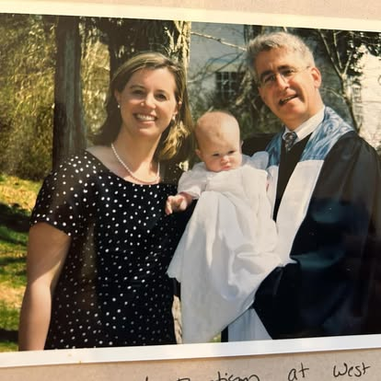

Lydia Baer, 3 months, with her parents Christie Burns and Reed Baer at her baptism at West Parish of Barnstable, UCC.

https://journeywithjesus.net/essays/2047-choosing-epiphany

