Trans Day of Visibility Service!
The Lost Sheep and What They Have to Teach Us
March 29, 2025
Fourth Saturday in Lent
Rev. Christine E. Burns

“Suppose one of you had a hundred sheep and lost one. Wouldn’t you leave the ninety-nine in the wilderness and go after the one lost one until you found it? When found, you can be sure you would put it across your shoulders, rejoicing, and when you got home call in your friends and neighbors, saying, ‘Celebrate with me! I’ve found my lost sheep! Count on it—there’s more joy in heaven over sinner’s rescued life than over ninety-nine good people in no need of rescue.” Luke 15:2-3

For those of us sitting in this Meetinghouse or watching online who are not trans, who was the first trans person you got to know in a meaningful way?
My first trans person I got to know was my boss! And Sandy Sorensen was a quiet, powerful trans woman who served for 32 years as the Director of the National Office of the United Church of Christ in an amazing building called the Methodist building which is located between the Senate and the United States Supreme Court. Commonly referred to as the “God Box” many religious organizations rent space there as well as non-profits who lobby Congress. The Methodists built this beautiful triangle shaped “God Box” when they were working to get the Prohibition passed nationally.
Sandy Sorensen was my boss when I was 22 years old and entering my second year of Divinity School at Harvard. I wanted to fulfill my work placement in a setting that wasn’t a church so I called up the National Office to see if they would let me intern for free for the summer. No fools, they checked my background and reached out to the Div. School and said they would accept this as a formal training site for me to see what ministry is like at the National setting. I called my job “Lobbying for Jesus”, and I do have pictures of me in a cute suit on the steps of the Capitol with a weird life size Jesus, but most the work I did all summer was work on preventing the repeal of Welfare Act under Clinton, called up the churches across the UCC to get them on board. It seemed like pastors were never in their offices. They didn’t work Fridays or Mondays. It was hard to get all the calls on Tuesdays through Thursdays.
And Sandy, she came in with her dowdy suits and pearls and quietly led the office. She was such a silent force of leadership. In an article celebrating Sandy’s 32-year service as the Director of the National office this is what people said about her. “Rain or shine, during stifling summers or icy winters in Washington, D.C., marching through the streets to the Supreme Court or risking arrest in the Capitol rotunda, no matter the circumstance, if you ask her, Sandy Sorensen shows up. A servant leader through and through, those who know Sorensen speak to her consistent presence and willingness to do what is needed in the fight for justice.
“If there are two words that could sum up the leadership of Sandy Sorensen it would be, ‘Go Team!’” said longtime colleague and former UCC staffer, the Rev. Loey Powell. “I have known and worked with Sandy for more than 20 years and have relied on her knowledge, her positive connections with interfaith and ecumenical partners, her insight and analytical capacities, and her humor to help the UCC navigate advocacy on a range of issues.
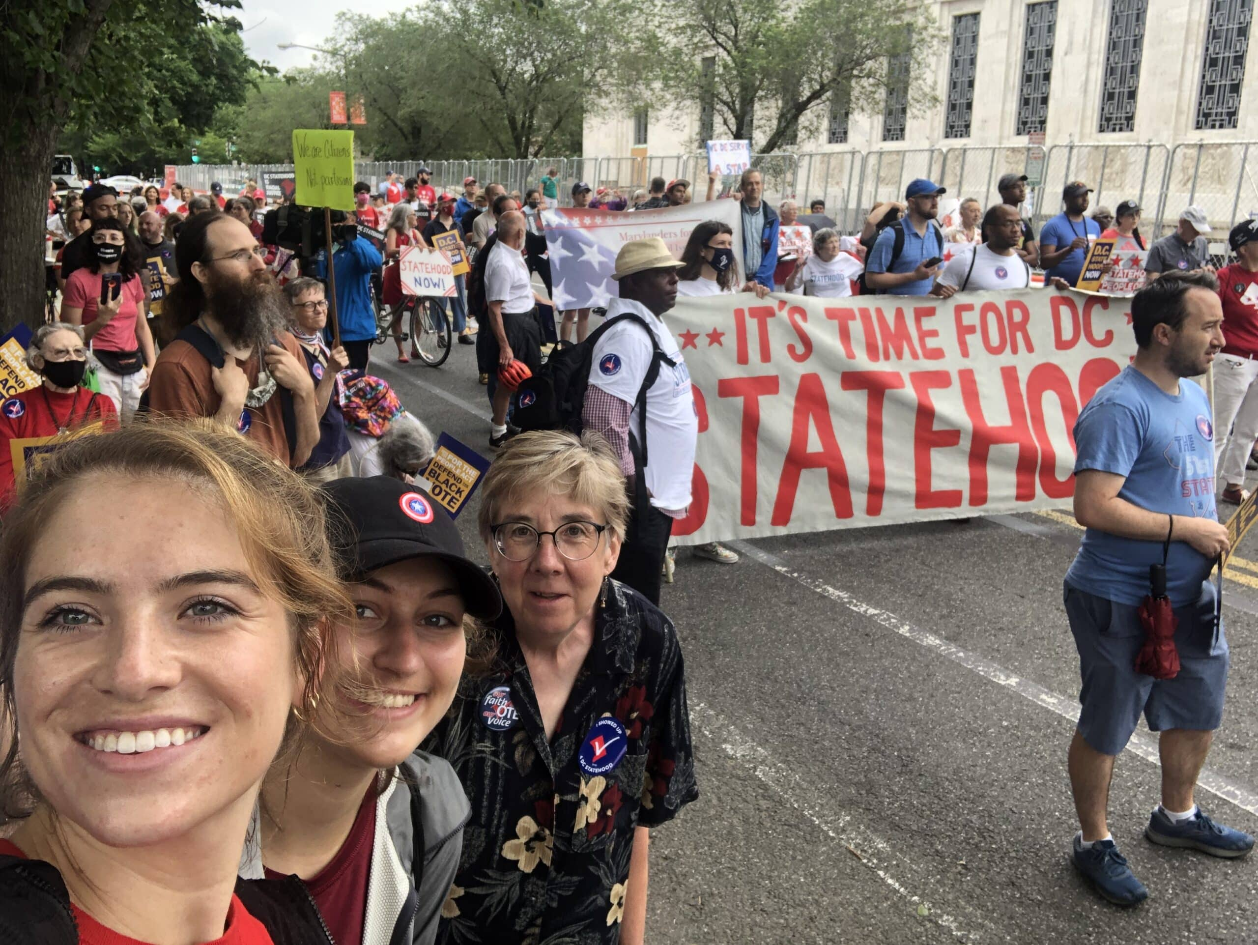
Jessica Quinn (far left) and Sophie Al Mutawaly (center) join Sandy Sorensen in 2021 at a march for Washington, D.C. statehood.
Sandy is still a faithful justice advocate, loves Women’s basketball, and animals.
Through Sandy’s team leadership, the United Church of Christ has been leading on justice and love work at the Capitol, at the White House, at the state level and across the country in our local churches.
I am so glad that my first experience with a trans gender person was Sandy. She truly opened the possibility of faith in action where when we think God is calling us to justice, we show up. Sandy was arrested for civil disobedience numerous times. And she always felt that now is always the right time to do the right thing.
Now, more than ever, we need people on the ground level in our communities, at the airport rotary in Hyannis, at the local schools and faith organizations, at the state house and the ballot box, at the White House and the Capitol to be standing up for love. For justice. For hope now.
We won’t always get it right, but we can do something.
This week, on March 31st, we celebrate Trans Visibility Day across the United States of America.
Our church, West Parish of Barnstable, UCC voted in 2005 this Statement of Welcome:

OUR STATEMENT OF WELCOME
As a congregation which covenants to walk together in Christian love,
believes that all persons are created equal before God,
and affirms the inclusive love of Jesus Christ,
we welcome to our work and worship all people
regardless of race, gender, age, ethnicity, sexual orientation, ability, or economic circumstance.
Adopted at Annual Meeting, June 26, 2005

We have many members of this church who are trans gender or have trans gender children. We want to look to the Bible where we find wonderful stories of inclusivity and love.
What does the Bible have to say about Trans Gender people?
For several decades, political and theological debates related to LGBTQ+ issues have centered around same-sex relationships for lesbian, gay and bisexual people. While an exploration of that topic is important, the volume of faith resources dedicated to it have often excluded reflection on the unique considerations related to gender identity. Mistakenly, some Christians have suggested that taking the Bible seriously requires people of faith to stand in opposition to the existence, health and humanity of transgender people. Consequently, gender-expansive people of all demographics and Christian traditions have been made to feel that they must choose between their faith and living a whole, healthy and authentic life.
When we use the word transgender, we are describing a person whose gender identity is different than the sex they were assigned at birth. It is an adjective, a descriptive word, and can encompass any variety of non-binary and gender-expansive identities.
When we use the term affirming, what we are referring to is the theological view that all expressions of gender are an integral part of God’s design for diversity within the created order.
Names are very important in the Bible and in affirming Trans gender people. There are many instances in the Bible of folks changing their names. In Genesis 32, Jacob wrestles in the dark and after that violent attack he takes on a new name of Israel because “struggled with God and with humans and [had] overcome” (Gen 32:28, NIV). Hagar a slave changes her name to El-roi meaning “one who sees.” And in Matthew 16 Simon changes his name to Peter as a signal that he would be “the rock” and foundation of the church.
Eunuchs existed in the Old Testament and the New Testament. In Biblical times, they didn’t use the word Trans-gender, but castration was common and eunuchs inhabited female spaces in Persian, Babylonian, Roman and some Jewish communities.
Jesus mentioned the eunuchs by name in Matthew saying there are many kinds of eunuchs including those who have been eunuchs from birth. (Matthew 19:12) And in the history book of the early church, the Acts of the Apostles, a eunuch asked if they could be baptized, and they were baptized without any questions or strings attached. (Acts 8:36)
God says we are each fearfully and wonderfully made.
If you are new to this conversation, it’s normal to feel overwhelmed, or fearful that other people will accuse you of affirming transgender and non-binary people merely because it seems politically correct or trendy. However, even though it is true that there has been an increase in transgender and non-binary visibility in media, or society has never seen as many trans-exclusionary bills in state legislatures, public faith statements made against transgender people in churches or higher rates recorded crimes committed against transgender people. Having the biblical and theological precedent I shared with you in this sermon doesn’t guarantee anyone protection from continued discrimination. It is always a dangerous and bold thing to come out in communities, especially communities of faith.
For those of you who are transgender, you are welcome here. For those of you who are non-binary, you are welcome here. For those of you who are not and are longing to be allies, you are welcome here. For those of you wondering why we are doing this, look around in our churches, look at your children and their friends, look at your community, transgender and non-binary folks have always lived among us.
As an Open and Affirming Congregation, we must do more than print a welcoming statement or a rainbow banner, we must live out love.
Today’s parable talks about the one lost sheep. Let me very clear here, our trans community is not the lost sheep. The lost sheep are anyone or group who sees a flock and forgets that God is the good shepherd and the one who runs away and forgets God is the one who hates, who rejects, who does not include all of God’s beloved children. In God there is no other. There are no other beings, we are all God’s human beings. And when one of us or one denomination or group of people in power, harms or kills another then we become the lost sheep.
You have heard the call. Is God calling your name to come back to the fold of love? Come home, come home. We are all called to be welcomed and loved into the Shepherd’s arms, and no one will be cast aside. You are fearfully and wonderfully made, just as you are. God loves you and so do we here at West Parish of Barnstable, United Church of Christ.
Amen.

https://www.ucc.org/celebrating-sorensens-32-year-legacy-of-advocacy-and-service/
https://www.hrc.org/resources/what-does-the-bible-say-about-transgender-people
https://www.hrc.org/resources/what-does-the-bible-say-about-transgender-people

