Halloween Happiness
October 17, 2026
Rev. Christine E. Burns

Even though I walk through the darkest valley,
I fear no evil,
for you are with me;
your rod and your staff,
they comfort me. Psalm 23: 4

I love that on Halloween and around the holiday, we get to play again. Imagination, make believe, dressing up in costumes, decorating with spooky elements and trick or treating with our children allow us to relive, if only for a moment, what it was to be a child.
What were your favorite costumes as a child?
Did you or your mom or dad make them or did you buy them at a store like Spirit?
Do you have any pictures of yourself in your costume?

My mom was an extremely creative teacher and did not believe in wasting money on buying costumes so we had homemade costumes. When we were little, she made the costumes. As soon as we got older, we had to make our own. As a preschooler, I was a little owl for several years as my mom cut a hole for my head and arms and had me color in the feathers for an owl, and wear tights and boots with a mask she made. It was adorable.
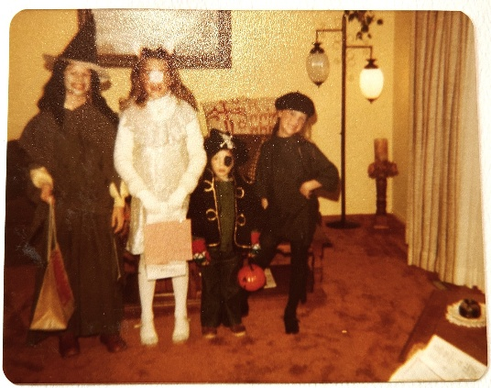
When I was six and seven, I was a black cat made out of black leotard and tights with a tail she made and a mask I made. I added a black wool beret from France and called myself a French cat. I loved that costume.

In middle school, I started getting my friends to make costumes with me including being a yellow crayon with a group of friends becoming a rainbow pack of Crayola crayons. Complete with yellow tights. Tights seem to be the key to homemade costumes.

I have four kids who are all adults now. By the time I was parenting them, I was all about buying costumes at Spirit. I’d let them each pick one costume. One kid, Julia, loved her Dalmatian costume so much, she wore it daily for months and carried a large Dalmatian pillow around the house long after Halloween. My son was obsessed with Toy Story 2 and loved Buzz Lightyear. He trick or treated in his Buzz costume and loved carrying Buzz around in costume. Our oldest daughter, Katie, convinced us to do the family Wizard of Oz costume when Camden was little and she was Dorothy and we filled out the other roles with baby Camden as Toto.
I’m now a grandmother, “Nana” is grandma name, to Sophie age 2 ½ and she is obsessed with Toy Story 4 right now. She decided to be Woody for Halloween so I asked her what I should be and she said, “Nana, you could be Jessie.” So, I am Jessie and Reed is Woody. On November 1st, I’m flying down to visit her and I’m bringing my Jessie costume so we can dress up together. I can’t believe I get to play make believe again.
That’s the thing about Halloween: it brings out happiness. It allows us to play, to laugh at the dark, to scare away things, to laugh at death a bit and eat way too much sugar. One year we had a Danish au pair, Pia, and she loved Halloween. In Denmark, they do not have our custom of trick or treating and receiving candy from neighborhood houses. She thought this was the coolest thing ever. When I was helping out a family who recently arrived in the United States from Peru, I took Emy, to the costume store and let her pick out her costume and her parents could not believe the things inside the Spirit store. She dressed up as a black and white doll that looked like a Dia de los Muertos doll and I took her and her parents’ trick or treating on Main Street in my village of Sandwich. Halloween night in Sandwich is a vision of what I think the kingdom of God can look like: hundreds of children and their parents walking safely at night, going from house to house and receiving hospitality and candy. There is no danger. People laugh and greet one another. My friends’ Tobin and Bob run a costume contest every year and pick a winner out of the hundreds of costumes that kids wear at their door and hand out full size candy bars.
I think that this is what God is like: welcoming us in our diversity, opening the door to strangers, handing out full size candy bars, welcoming the children first, creating a safe world for all people regardless of where they come from, who they vote for, what socioeconomic class they live in. Everyone is welcomed and celebrated. You knock, someone opens the door and say, “trick or treat.” And the answer is always a treat. There is never a trick.
God welcomes all of us, young and old. And we know Jesus welcomed the children first. We need to remember that. It is our job to protect them. To love them. To make the world safe for them and to allow the happiness of Halloween to last for more than one night. I love that we offer Trunk or Treat. Halloween can begin early. The church says, come, all you who are hungry. Welcome to the table, here all are welcome. Come all who are hungry and have some free pizza and then lots of candy. Come and find that you belong and are loved.
All week long, we work very hard to love and educate our children at West Parish Family School. We have amazing teachers and staff who are constantly learning how to better care for your children. I feel so lucky that I get to go into the Pre-K classrooms and read every Tuesday. I witness how wonderful your kids are and I see them in the playground and in Jenkins Hall. We love your kids.
Today’s scripture reading is from the 23rd Psalm. I picked it because it is perhaps the Psalm most well-known among Jewish and Christian followers. We use the Psalm when someone is dying and at funerals as it helps us to see how the Lord is our shepherd. It begins with quiet and nature, with the Lord as our shepherd; inviting us to lie down in green pastures. And then acknowledges the dangers of the world and nature. In the next verse, we learn that “Even though I walk through the darkest valley, I fear no evil; for you are with me; your rod and your staff—they comfort me.” (Psalm 23:4) In that agrarian society, evil and danger did seem to lurk everywhere. There was no electricity. Night was very dark, especially on a cloudy evening without the stars or the moon to light the path. And shepherds spent many hours, even nights out in the wilderness. There was much to fear. And David says to them that “You prepare a table before me, in the presence of my enemies; you anoint my head with oil: my cup overflows. Surely goodness and mercy shall follow me all the days of my life, and I shall dwell in the house of the Lord my whole life long.” (Psalm 23: 5-6)

That is the world, and the life afterwards that I long for. I long for a world where my children and your children, all our children, shall be surrounded with goodness and mercy and at the end of our lives, that it is only the beginning. For then, we will begin again, in the house of the Lord for eternity. Amen.

