The Compassionate Life

“Teacher, which commandment in the law is the greatest? He said to him, ‘You shall love the Lord your God with all your heart, and with all your soul, and with all your mind.
And the second is like it: “You shall love your neighbor as yourself.’” Matthew 22: 36-39)

October 24, 2026
Rev. Christine E. Burns

I was sitting in a coffee shop speaking with a friend about life and she shared a story about her journey with cancer years ago. Driving down the highway to another appointment for radiation at Dana Farber in Boston, exhausted and completely worn out, she saw a spray-painted sign on an overpass that said “I LOVE” and the name was wiped clean. She decided that was a sign from God that in the middle of her pain and exhaustion this was her mandate and mission. God was calling her to love. To love herself and her body suffering from the indignity of chemo, radiation and surgery, to love her family, to love her community. And she started taking her skills as a baker and began making meals for the homeless each month in Hyannis. She would make a hundred homemade rolls and huge pots of warm soups and stews because people are hungry. She didn’t wait until she knew the cancer was in remission. She started loving her neighbor and herself on that highway.
I was gob smacked.
I have never received a sign from above like that and I am a preacher.
Perhaps you have. I would love to hear your stories of receiving a sign in any form: perhaps the love of a dog, or the sight of a blue heron flying over the marsh. Maybe you heard it in the voice of a patient in a hospital room or a parent leaving you last instructions as they prepared to die. But I hope that we can pay attention to the voice of God in the form of people and spray-painted signs on highway overpasses that remind us who we are and what we are called to do. We are called to love.

Too often we choose fear rather than love. And in this current time period, as we wait for an election, fear runs through our national discourse. Today, we choose love.
I have three poems by the Australian poet and cartoonist Michael Leung to begin our exploration of what Jesus meant when he gave us the two Great Commandments.

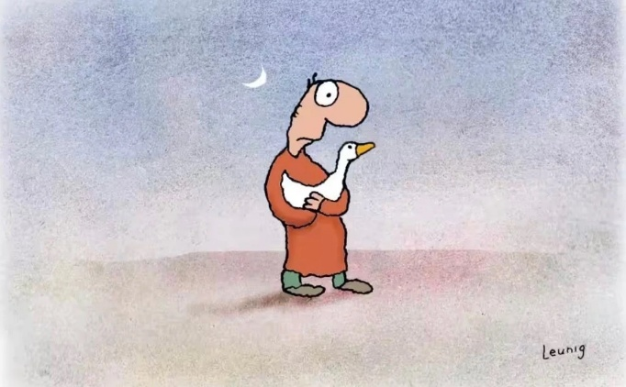
There are only two feelings.
Love and fear.
There are only two languages.
Love and fear.
There are only two activities.
Love and fear.
There are only two motives,
two procedures, two frameworks,
two results.
Love and fear.
Love and fear.
+
God help us to change.
To change ourselves and to change our world.
To know the need for it.
To deal with the pain of it.
To feel the joy of it.
To undertake the journey without understanding the destination.
The art of gentle revolution.
Amen.
+
God, help me to live slowly
To move simply
To look softly
To allow emptiness
And to let the heart create for us.
Amen.
Michael Leunig was an Australian cartoonist and poet. In 1999, he was declared a National Living Treasure by the National Trust of Australia. Here’s one of his classic poems and three of his brief, beloved prayers. For more, check out his collection, A Common Prayer: A Cartoonist Talks to God.

“God help us to change. To change ourselves and to change our world.” Wow, that is the invitation of Jesus’ commandments. We are called to be transformed. We are called to love one another. To love our neighbor who we do not like. Who we do not look like. Who we disagree with. Who we do not vote with. Who we are at war with. For in Christ, there is no other. We are all neighbors. And we are called to change ourselves. To look in the mirror and see our flaws but not become discouraged, disheartened or disgusted.
We are called to say, here I am God. This is me. A little older, a little wearier, a little more cynical. Can I change myself enough to be your disciple in the world? Can I go out from this room and love the people in my house who can be extremely tiresome and rude? Can I get into my car and refuse to return aggression with road rage? Can I walk into the shops and grocery store and acknowledge the face of God in those I pass obstructing my attempt to race through the aisles in record time to get home and make a meal passing as healthy before the hunger turns to hanger at our homes? Can I go to work and slow down enough to hear the music underneath the words of my coworkers who need some love and sympathy? Can I slow down my need to be productive enough to realize that we are called to do things that do not compute, that do not make a profit? We are called to simply exist in ordinary time and recognize we are mortal and those around us are as well. May we listen with love When people know that they are being heard, truly heard, it feels an awful lot like love. Teach us this practice God. This would be a revolution indeed.

Our lectionary text comes from the Gospel according to Matthew and in it is the the last of three parables that attempt to trap Jesus with trick questions using his own words. For Matthew, the love commandment is preeminent: all other commandments are subsidiary and to be performed out of love for God and love for our neighbor. “It was a common exercise among religious scholars of the day to debate which of the 613 commandments in the law is “the greatest,” meaning the one that sums up the essence of the whole, or serves as the hub at the center of them all. The so-called “Shema” (or “Listen”) figured largely in Israelite liturgy and life: “You shall love the LORD your God with all your heart, and with all your soul, and with all your might” (Deut 6:5). “Love your neighbor as yourself” is from Leviticus 19:18, a relatively minor commandment among the 613.”

Jesus said that “On these two commandments hang all the law and the prophets” (Matt 22:40). The Mishnah, a collection of Jewish legal and exegetical teaching, includes the idea that the world “hangs” on the Torah, like a coat hanging on a peg — and here Jesus is saying, in effect, that the Torah itself “hangs” on extravagantly loving God and neighbor.”

What is this Love all about? It is about the love of community. And how do we build this kind of love: by listening and forgiving. I love that.

Last night we had a fabulous gala celebration of the 50th anniversary of West Parish Family School and so many of our church members, Family School parents and community members came to celebrate and plan for a future for our children on Cape Cod. This is the kind of love of neighbor we are called to serve. We will build a future for them, we will plant trees for the next generation, not because of what we will get out of it, but because this is what love made real in the world looks like. Jesus called the children first to sit at this feet. He listened to them and loved them. We are called to do likewise. Not because they will fill our pews each Saturday or Sunday, but because our children on Cape Cod deserve the best education, protection, childcare and love we can provide. IF we wonder what Jesus would do, let us figure out who the most vulnerable are today, in our community and provide for them. At West Parish Family School, we educate some children for free with help from the state who are financially in need. We educate children with a diversity of special needs and have trained special education teachers who can provide one on one care for them. And we have administrators who help our teachers grow as educators, allowing them to gain more accreditation and skills while working full time as teachers at our school. The glow of the gala may fade, but the vision of an early education with a difference remains.
I hope we can all get excited about how we can love our littlest ones here at West Parish Family School and across the globe. Our neighbors live next door, and in the Ukraine. Our neighbors are beside us in Canada and Mexico. Our neighbors share ocean borders and always, it is the children who need to be protected and loved. As Fred Rogers said, “Won’t you let me be your neighbor?” It is a beautiful day in the neighborhood, let us love all those who we meet after we take off our cardigans and put on our street shoes and start walking around the neighborhood. If we open up our eyes to see, our ears to listen and are hearts to be transformed, we have a chance to become ones who love like Christ. We have been given the two great commandments. How we respond to them; with love or fear is our choice. Choose wisely my friends. Amen.

https://www.saltproject.org/progressive-christian-blog/2026/10/19/a-poem-and-three-prayers-by-michael-leunig
https://www.saltproject.org/progressive-christian-blog/2020/10/19/two-kinds-of-love-salts-lectionary-commentary-for-twenty-first-week-after-pentecost
Ibid.

